Infrared Camera Recipe for Astronomy

Christopher Rooney

# Introduction

The infrared camera demo is a fun and accessible introduction to the electromagnetic spectrum, and the fact that different wavelength regimes can be used for very different purposes. Infrared light does not always behave in an intuitive way, and allowing the general public to explore the properties of infrared radiation in an informal setting demonstrates the advantages and drawbacks of infrared light for astronomical observations. For years, the Cornell Astronomy Department has hosted Infrared Camera demonstrations for Education and Public Outreach (EPO), however the infrared camera that has historically been used for these demos at Cornell was recently broken. Commercially available infrared cameras with support for external monitors or projectors can be prohibitively expensive for outreach budgets. In this document, we present an inexpensive and straightforward recipe for a modern infrared camera.

# Supplies needed

The first item in each bullet point is the item I used, and will work without modifications, but modifications may be required for other items.

* SEEK Thermal PRO camera [Micro-USB](https://www.amazon.com/Seek-UQ-AAA-Compactpro-Android/dp/B01LXM0BSH?ref_=ast_sto_dp&th=1&psc=1) **or** [USB-C](https://www.amazon.com/Seek-Thermal-CompactPRO-Resolution-Imaging/dp/B07V34RFLW?ref_=ast_sto_dp&th=1&psc=1) (~$500)
* Micro-USB to USB-A adapter (Pictured) **or** [adapter](https://www.amazon.com/Pack-Micro-Female-Adapter-Converter/dp/B0986SYF6L/ref=sr_1_16?crid=IQLSVDQILFJ7&keywords=usb+2.0+usb-a+male+to+usb-micro+female+cable&qid=1669061694&sprefix=usb+2.0+usb-a+male+to+usb-micro+female+cable%2Caps%2C100&sr=8-16) and [extension cable](https://www.amazon.com/AmazonBasics-Extension-Cable-Male-Female/dp/B00NH11PEY/ref=sr_1_3?keywords=usb+extension+cable&qid=1669061802&sr=8-3) **or** USB-C extension cable ([example](https://www.amazon.com/Faracent-Extension-Charging-Nintendo-Touchbar/dp/B071DMMW4J/ref=sr_1_3?keywords=usb+c+extension+cable&qid=1669061521&sr=8-3))

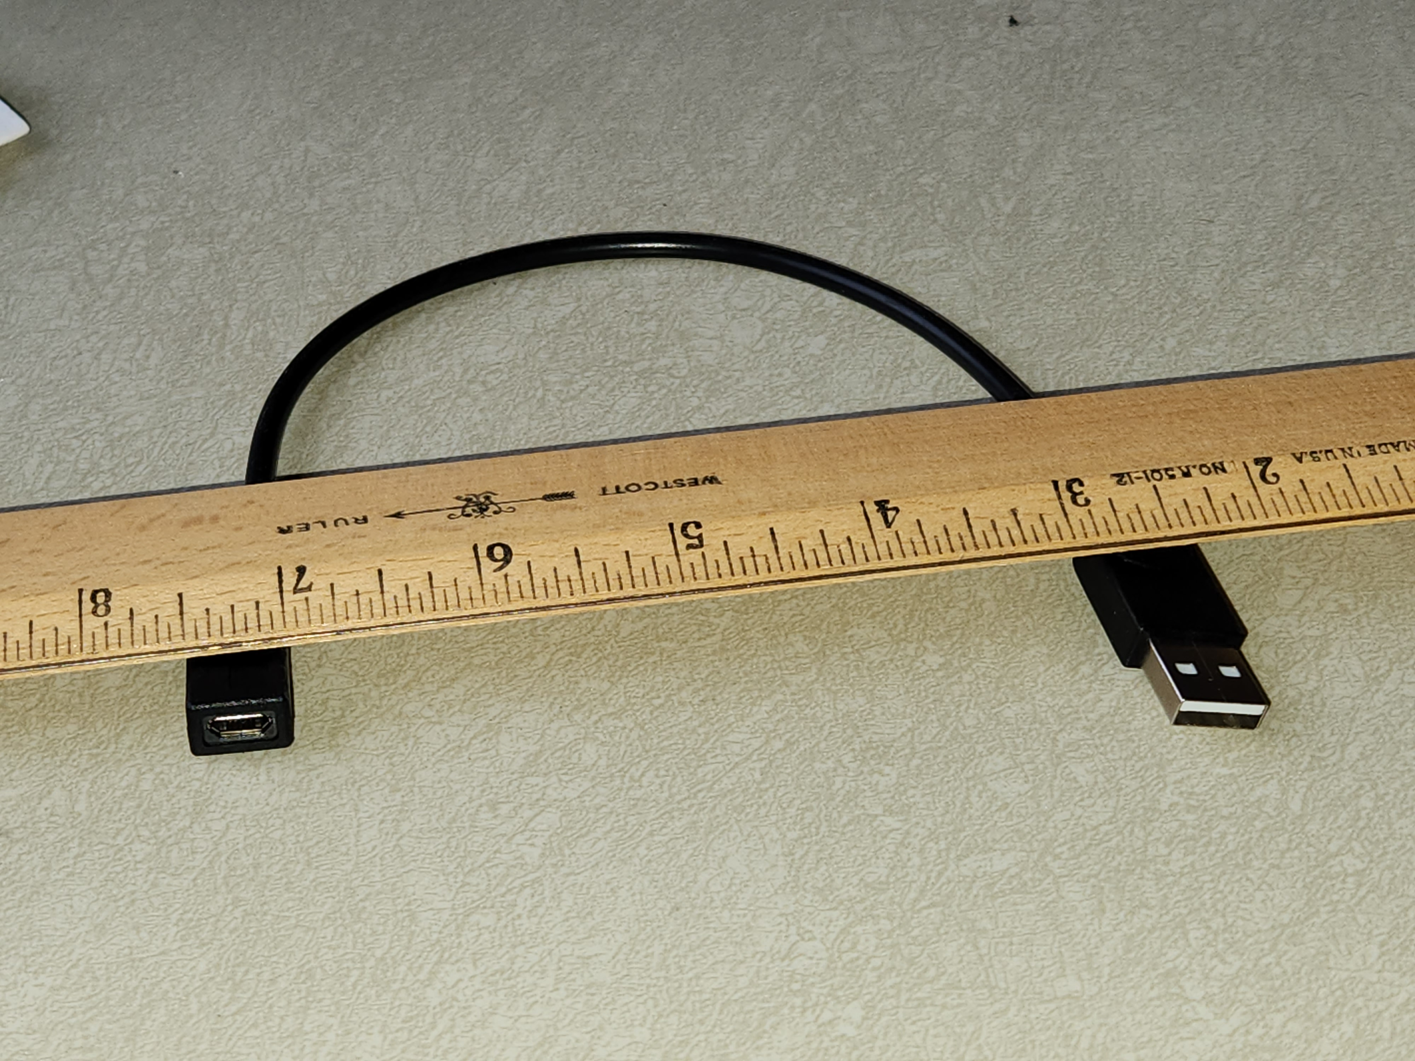

* Laptop
  + Mac or Linux (Ubuntu recommended) OS
    - Windows support is claimed, but I have not tested it.
  + USB-A and/or USB-C port (x2)
  + HDMI port
* [Razer Kiyo](https://www.razer.com/streaming-cameras/razer-kiyo) webcam or any webcam
* 3D printed webcam/camera stand (pictured, designed specifically for Razer Kiyo and the usb-micro adapter listed above)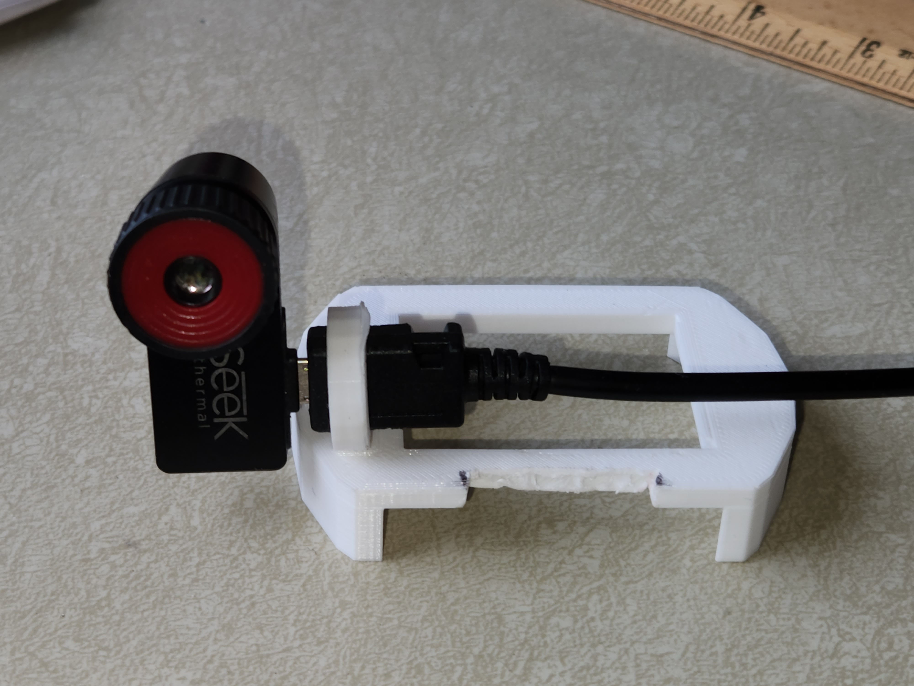

# First-time setup

The driver for the camera exists as C++ source code. My version of the code is available on [GitHub](https://github.com/NanoExplorer/libseek-thermal). Clone the "main” branch and follow the instructions in the README file to compile the program. To do this, you will need either the git command line program or the GitHub Desktop program.

Open Broadcasting Software (OBS) can be used to composite the webcam and infrared images onto a projector or TV screen, and is available from the Ubuntu software repositories and its website (<https://obsproject.com/>).

# Running the camera driver

In a terminal, navigate to the “build/examples” folder and run:

./seek_viewer -t seekpro -c11 -r 180 -s 2

If the program exits immediately with an error message, unplug the USB cable for the camera, plug it back in, and rerun the command. If that also fails, try using the make command to rebuild the program (this often happens when other software updates are installed)

If successful, a window will pop up with a live view of the thermal camera. Congratulations! You can now display a basic thermal image on a projector by connecting your computer and moving the window or mirroring your screen.

## Tips for a more polished image

To ensure optimal image quality, a calibration script has been included with the driver. To take advantage of this feature, point the camera at something with a uniform temperature (e.g. cover the lens with your finger or diffuse surface such as cardboard) and run the following command:

./seek_create_flat_field -o flatfile.png

The created flat file is calibrated so that the viewer program can correct for variability in the sensitivity of each pixel and produce the clearest possible image. Once the flat field program is finished, run the viewer program with one extra argument:

./seek_viewer -t seekpro -c11 -r 180 -s 2 -F flatfile.png

You may need to re-run the flat field program at intervals due to drift in detector response.

## Advanced usage

The viewer can accept several arguments. The –c argument chooses a color scheme for the output image, where a number from 1-12 represents each color scheme. Scheme number 11 is a black-red-orange-yellow-white color scheme that represents thermal images nicely. The –r command ensures that the image is rotated properly. Use values of 0, 90, 180, or 270 until the image is right-side up. The –s 2 argument scales the image up by a factor of two.

# Configuring OBS

My OBS settings are available in the GitHub repo, however OBS depends on the exact hardware and operating system configuration to select the correct windows and devices, so tweaking may be required. To import the scenes file, go to the Scene Collection menu and click “import,” then find the Git folder and the obs_scenes file.

The important scene is called Scene. Make sure this is selected. The “Sources” box should show a “Window Capture” and a “Video Capture.” Likely nothing will be displayed in the preview at first, so you will need to point these sources to the correct places. Double click on the Video Capture source and change the Device, then click OK; repeat this step until the correct video feed is displayed in the preview. With the seek viewer program running, double click the “Window Capture” source, and change the Window to point at the seek viewer window (it may have a strange name like “OpenCV”). The crop settings can be modified to ensure that the title bar and status bar are not displayed on the projector for a cleaner view.

Now the preview window should be displaying a side-by-side view of the IR camera and the standard webcam. Adjust the positioning of the two until they cover approximately the same field of view. You can also drag the various screens around on the preview window and rescale them.

OBS can produce a full-screen view of the side-by-side IR camera and visible light camera. To activate this mode, right-click on the preview window and find the option labeled “Fullscreen projector (preview)”, and then select the screen you would like to use for the video.

# The Demo Itself

Depending on the age range of the audience, you can select which activities you would like to run. Some good activities are listed below.

* Give each kid an ice cube. They will see it as a very dark/black spot on the camera feed. They can use it to “draw” on their faces, hands, arms, or cardboard (e.g. paper plates) leaving behind cold “writing.” Explain that the areas of their skin that appear darker were cooled down by the ice, or there is a thin film of cold water covering their skin.
* Ask the students what they think will happen if you place an opaque plastic trash bag in front of the camera. Trash bags are opaque in the optical, but transparent in the infrared. Here a parallel can be drawn to interstellar dust, which can obscure star and planet formation. Infrared telescopes allow us to see even dust-obscured star formation, because infrared light goes through dust just like it goes through the trash bag. Another point of emphasis can be the parallels between the IR camera and the JWST. The wavelength range used by the IR camera is a subset of the wavelengths available to JWST.
* Repeat the above activity with a pane of glass. Infrared light cannot pass through the glass, while visible light can. This is what causes cars to become so hot in the sun. Most of the Sun’s energy is radiated in the Visible part of the spectrum, but when it is absorbed by a dark car interior it is reradiated as infrared light. This infrared light is then blocked from exiting the car as easily as the visible light entered, trapping heat inside. This is very similar to the greenhouse effect, which prevents the Earth from being an ice ball.
* Fill two identical mugs with hot and cold water and ask the students to identify which is which and justify their answers. Students may note that the hot water vessel looks in the IR like a crucible of molten metal. You can expand on this parallel by explaining the properties of blackbody radiation, especially Wien’s law.
* Present two identical thermos bottles containing hot and cold water and explain that the double-walled structure of the thermos allows most of the infrared radiation to be trapped inside the thermos, keeping your coffee warm or your drink cold.
* Use a hair dryer to blow on your hair or someone else’s (with permission!) Note that your hair lights up very quickly because it has very little mass and so its temperature can be changed easily.
* Observe other things in the room, like winter coats (which trap heat inside of them and appear dark outside), glasses (which are usually dark because they are made of glass), etc.
* A more advanced demo would be to fill a resealable bag with water and compare it with an empty bag. The water will absorb all the infrared light, as an analogue for water vapor in the atmosphere, which hinders ground-based infrared astronomy.
* Leslie’s Cube can be used as an introduction to the effect of emissivity on radiation. It has three faces, one painted black, one with a mirror finish, and one is unpolished aluminum. Although all three surfaces are maintained at the same temperature by the underlying solid aluminum cube, the three faces will appear to have very different temperatures when viewed with the IR camera.
* Thermal-sensitive paper is one of the few objects that can look the same to the eye and to the IR camera! Place a warm handprint on the thermal paper and observe that this handprint is now visible to both your eye and the IR camera.

# Conclusion

We have discussed the procedures for purchasing, setting up, and running an infrared camera demo for EPO. This method is considerably more affordable for outreach budgets than commercially available cameras with comparable capabilities and is sufficient quality to provide meaningful experiences for students and the general public.